Out put of the mathematically model

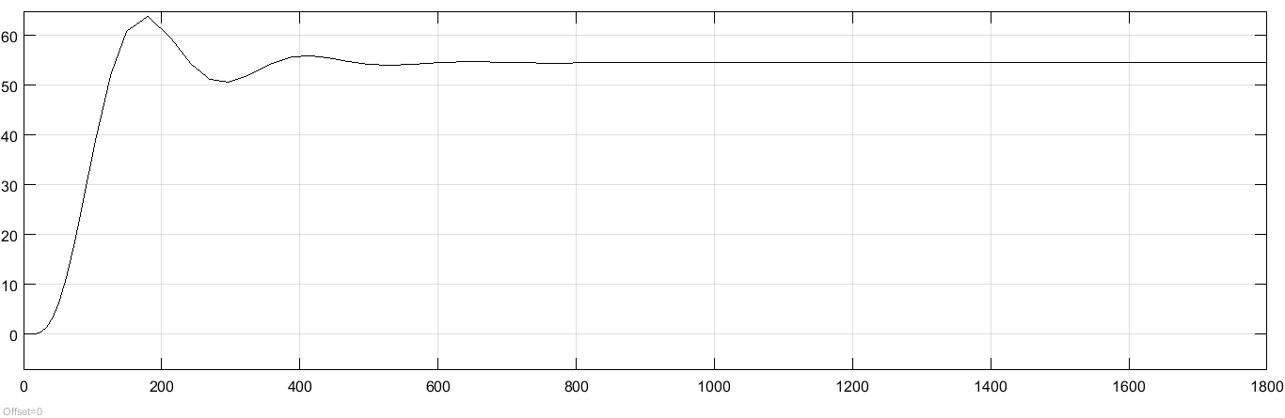

After regulation with pid Controller

